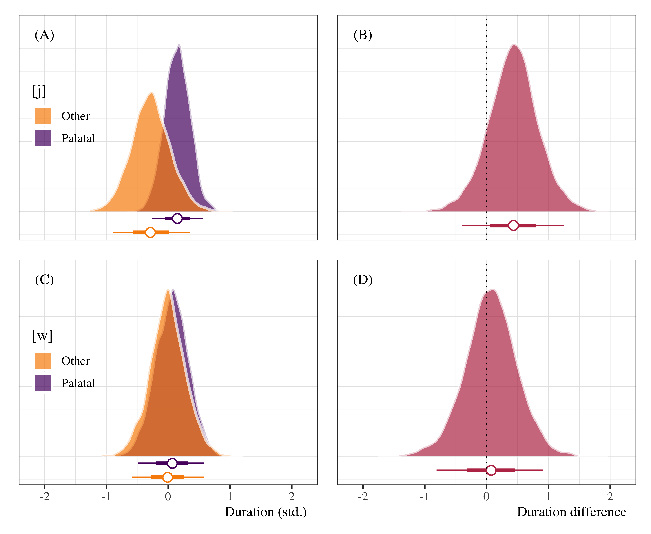

Figure 4.2: Posterior distributions of pre-vocalic glide duration (panels A and C) following palatal and non-palatal onsets, as well as duration difference plots (panels B and D). Points represent posterior medians ±66% and 95% credible intervals.